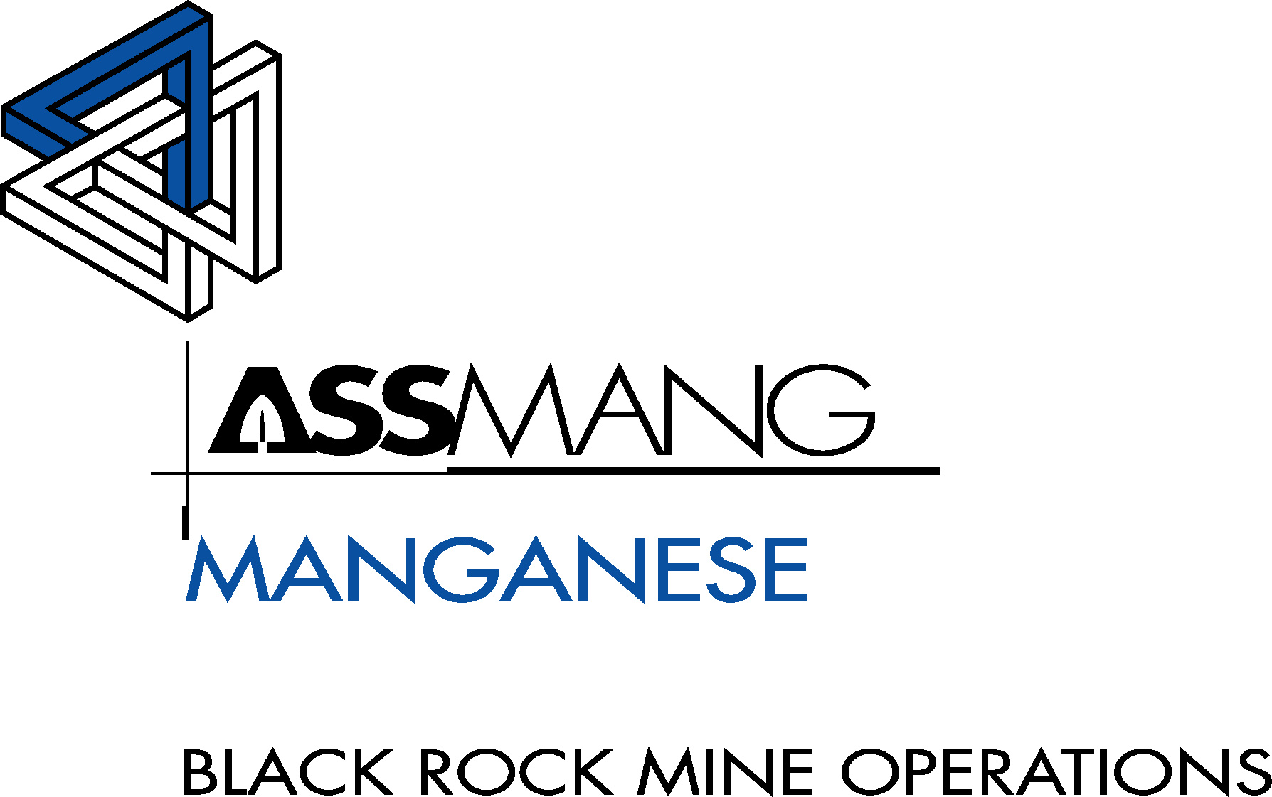
Memorandum
POSTAL ADDRESS:
P.O. BOX 187
8491, SANTOY
SOUTH AFRICA

TEL:
(27 53) 751 5555

FAX:
(27 53) 751 5251

To: | Manager HR | Thulie Gxothelwa
 | Manager Engineering | Jacques Breet
 | Manager Finance | Niresha Ramlugan
 | Senior General Manager-Interim | Rudi Opperman

From: Senior Production Engineer – G Karsten
Date: 21 November 2025

RE: Create New Position: N3 UG Electrical Foreman

Background
The Nchwaning 3 Underground Electrical section is responsible for maintaining and expanding the electrical infrastructure that supports production, development, pumping, ventilation, fixed plant and safety systems over a 3–4 km underground footprint at Nchwaning 3. The current scope includes, amongst others:

Power distribution & infrastructure
- ±73 minisubs (distribution substations)
- 6 main substations
- 400+ gulley boxes (local distribution points)
- Main dams and pump stations (including 48-stage pumps)
- 4 shaft bottom pump stations (incl. 3.3 kV pumps)

Ventilation, dewatering and services
- ±150 fans, including 9 Donkin fans
- ±120 submersible pumps
- Fixed services to buildings, waiting places, workshops including BEV Bay and refuge bays
- ±22 km LED lighting across access and production areas
- Leaky feeder networks for underground communications,
- Blasting infrastructure including BCUs and blasting terminators

Fixed plant and conveyors
- Surface and underground plant including crushers, screens and pumps
- Conveyors and feeders, including decline belts with pull-keys and interlocks
- 11 rock breakers

Mobile and production equipment support
- 3 major production sections and 1 development section
- HDs and RTs – ±22 units service and production support

In addition to the day-to-day operation and maintenance of minisubs, gulley boxes, fans, pumps, conveyors, crushers, rock breakers and fixed plant, the section must also:
- Execute preventative maintenance (PMs), legal inspections and statutory tests (substations, minisubs, conveyors, pumps, gulley boxes, 6-monthly e/l tests, etc.).
- Carry out forward moves and new installations (power, lighting, leaky feeder, blasting boxes, fans, pumps) to enable production and development advance.

All of the above is currently supervised and coordinated through a single foreman, who is responsible for both breakdown support and planned construction/installation activities across the entire mine.

Problem Statement
The single-foreman at N3 Underground Electrical is no longer adequate for the current and planned workload due to expanding size and scope of work as the mine develops. Key risks are:
- Legal Compliance Risk
- Inability to consistently meet the inspection, test and documentation requirements across all electrical assets.
- Increased risk of non-compliance during DMR audits and internal governance reviews.
- Production Risk
- Infrastructure forward moves (power, lighting, leaky feeder, pumps, fans) are delayed when breakdowns take priority.
- Development and production sections experience avoidable delays waiting for electrical readiness.
- Safety Risk
- Rushed installations and limited supervision across a large geographic area.
- High reliance on a single foreman to manage both reactive and planned work, increasing the risk of oversight.
- Capacity Constraint
  - Aging infrastructure (minisubs, gulley boxes, cables, pumps) requires structured replacement, but current capacity is absorbed by breakdowns.
  - BEV and other new initiatives add to the workload without corresponding supervisory capacity.

Proposal
We propose the creation of a new Foreman position at Nchwaning 3 Underground Electrical, dedicated to Construction & Infrastructure, while the existing foreman focuses on Production Support & Services.

The Foreman – Nchwaning 3 Underground Electrical (Construction & Infrastructure) will have the following high-level responsibilities:
  - Plan and supervise forward moves of electrical infrastructure (power, lighting, leaky feeder, blasting boxes, fans, pumps).
  - Coordinate and oversee minisub installations, relocations and upgrades.
  - Manage installation quality, QA/QC, and ensure compliance with MHSA, COPs and OEM standards on new and modified infrastructure.
  - Drive planned projects and upgrades (including BEV-related electrical infrastructure) without interruption from day-to-day breakdowns.
  - Ensure legal inspections and PMs for infrastructure under his/her responsibility are scheduled and completed on time
  - Work in close collaboration with the existing Foreman (Breakdown & Services) to balance priorities and ensure smooth handover between reactive and planned work.

The Foreman for Production Support & Services will be repsonsible:
  - Breakdown response and services to production equipment and infrastructure.
  - Support to load & haul, drill & blast, and utilities workshops.
  - Legal and preventative maintenance on equipment directly impacting daily production.

Expected Benefits
  - Improved Production support
  - Clear accountability for infrastructure inspections and PMs.
  - Reduced risk of non-compliance
  - Forward moves and new installations proceed according to plan, instead of being delayed by breakdowns.
  - Better readiness of new panels, sections and projects through dedicated infrastructure supervision.
  - Enhanced Safety and Quality and better supervision of installations reduces rushed work and rework.
  - Improved oversight across a wide operational footprint, reducing the likelihood of unsafe conditions developing unnoticed.
  - Reduced dependency on a single foreman as a “single point of failure” for supervision and decision-making.
  - Better workload balance, improving morale and retention of artisans and assistants.

Conclusion
The current supervisory structure at Nchwaning 3 Underground Electrical is at maximum capacity. The combination of:
  - Large and aging electrical infrastructure,
  - Expanding production and development requirements, and
  - Increasing statutory and project demands
makes the creation of a dedicated Electrical Foreman (Construction & Infrastructure) at N3 an operational necessity.

Recommendation:
Approve the creation and appointment of Foreman – Nchwaning 3 Underground Electrical (Construction & Infrastructure) with immediate effect and initiate the recruitment process.

G Karsten
Senior Production Engineer

Thulie Gxotelwa |  | Jacques Breet
HR Manager |  | Engineering Manager
Niresha Ramlugan |  | Rudi Opperman
Manager Finance |  | Senior General Manager - Interim

